The virtual course on The Science of Buying Bunkers, led by Ms Irene Notias, Founder & MD, Prime’s Bunkersplus Services on 24 – 25 May 2021, attracted purchasing officers, bunker managers, commercial executives, managers in tanker & shipping operations, who were from companies involved in shipowning, ship management, bunker supply & port management, attending from UAE, South Africa, Sri Lanka & Singapore.

The course guided participants through best practices for effective bunker fuel procurement. A special feature of the course “The Bunker Game”, was a role play with delegates, providing techniques & processes in handling a bunker inquiry effectively including exposure to real time prices.

Testimonials

“Very informative for those who want an insight on the buying and selling aspects of bunkers. For newcomers, a must. For those already in the industry, its about gaining more updated information.” SVP, Miyabi Industries Pte Ltd

“I appreciated the refresher course offered as well as the new concepts I learnt. All the information was adaptable and may be applied to my every day work.” Manager, Africa Bunkering & Shipping

“Beneficial as a primer on how bunkers are bought and sold, trade flows and supply chain links are also discussed. Good variety of knowledge sharing by different panel guests.” Kenrick Tan, Graduating Student, NTU

Upcoming courses 15 & 16th November.

Should you be interested to attend, or to receive info for future events, register at info@cconnection.org .

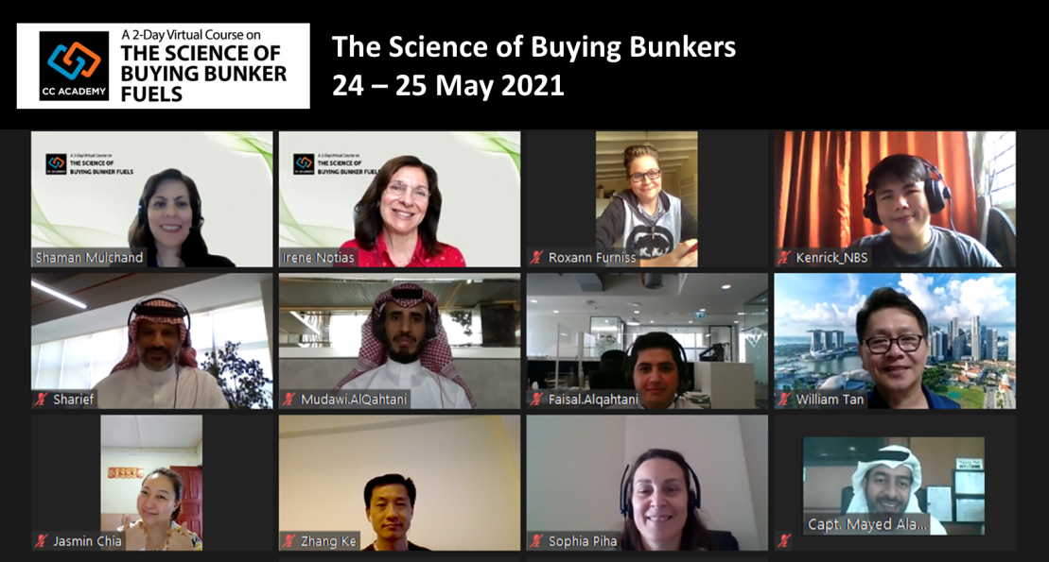 | 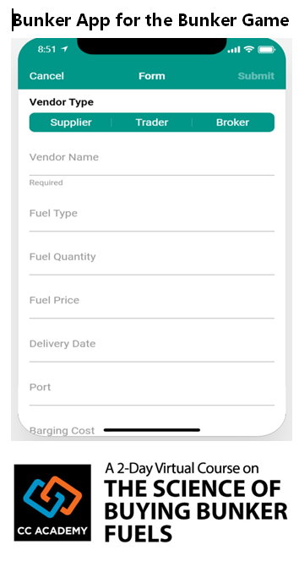

Testimonials for the course Bunker App for the Bunker Game
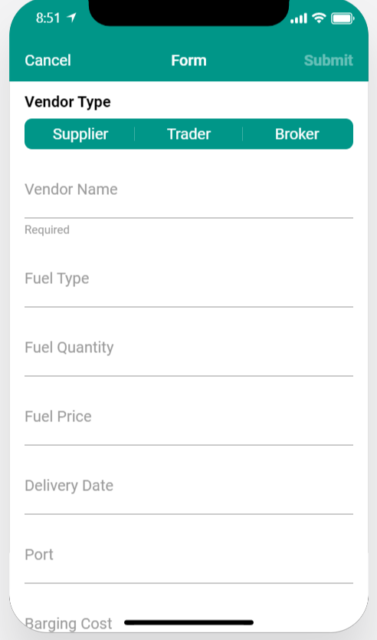
“Very informative for those who want an insight on the buying and selling aspects of bunkers. For newcomers, a must. For those already in the industry, its about gaining more updated information.” SVP, Miyabi Industries Pte Ltd

“I appreciated the refresher the course offered as well as the new concepts I learnt. All the information was adaptable and may be applied to my every day work.” Manager, Africa Bunkering & Shipping

“Beneficial as a primer on how bunkers are bought and sold, trade flows and supply chain links are also discussed. Good variety of knowledge sharing by different panel guests.” Kenrick Tan, Graduating Student, NTU

